
COS40007 ARTIFICIAL INTELLIGENCE FOR ENGINEERING
Design Project Theme 3: Smart Government

Prepared by E’s Island:
Kenneth Hui Hong CHUA 102782494
Kelvin Wen Kiong FONG 102782287
Nigel Zi Jun LING 102779140
Neng Yi CHIENG 104386364

Contents
1 Introduction 3
1.1 Background and Motivation 3
1.2 Project Objectives 3
1.3 Summary of Outcomes 3
2 Dataset 5
2.1 Data Source 5
2.2 Data Processing 5
3 AI model development 7
3.1 Feature engineering / Feature extraction 7
3.2 Train/Test split 7
3.3 Training model 7
3.3.1 Clustering: K-Means and Agglomerative Hierarchical 7
3.3.2 Time series: ARIMA(2,1,2) 8
3.4 Evaluation of AI model 9
3.4.1 Clustering validity 9
3.4.2 Forecast accuracy 11
3.4.3 Discovered trends 12
3.4.4 Real world reliability check 13
4 AI demonstrator 14
5 Conclusions 17
5.1 Challenges and how we overcame them 17
5.2 What we learnt 17
6 References 18
7 Appendix A 19
7.1 A.1 Reproducing the analysis 19
7.2 A.2 Project deliverables and shareable links 19
7.3 A.3 Additional per state forecast figures 19

Introduction

Background and Motivation
Income levels and consumer price inflation are two of the most closely watched indicators of economic wellbeing in Malaysia. The Department of Statistics Malaysia (DOSM) publishes monthly CPI data at both national and state level, alongside periodic household income surveys, giving researchers a rich longitudinal and cross-sectional picture of the economy. Yet aggregate national averages can conceal important regional variation: states differ substantially in both their income levels and their exposure to inflationary pressure, and understanding these differences matters for designing targeted subsidies, social-protection schemes, and monetary policy.
Under the COS40007 Smart Government theme, this project applies two complementary AI methods to open DOSM data: ARIMA time-series forecasting to predict how national CPI inflation will evolve over the next 24 months, and unsupervised clustering to group Malaysia's 16 states into interpretable economic tiers based on their CPI and household-income profiles. The analysis is wrapped in a reproducible Python pipeline and an interactive Flask dashboard so that the findings are accessible to non-technical policymakers.

Project Objectives
The project set out to achieve the following objectives:
• Forecast national CPI inflation. Fit and evaluate an ARIMA model on Malaysia's monthly overall CPI inflation-on-year series (Jan 1981–Apr 2026), generating a 24-month ahead forecast with confidence intervals.
• Cluster states by economic profile. Use K-Means and agglomerative hierarchical clustering to segment the 16 states into interpretable economic tiers from CPI index, CPI growth, CPI volatility, and household income features.
• Quantify fuel-price pass-through. Measure the contemporaneous and lagged correlation between retail fuel prices (RON95, RON97, diesel) and overall CPI inflation.
• Validate against official statistics. Cross-check every headline result against DOSM published figures to ensure real-world reliability.
• Deliver an interactive demonstrator. Package the analysis into a Flask web dashboard so non-technical stakeholders can explore the findings without running code.

Summary of Outcomes
All four DOSM datasets were processed through a single reproducible pipeline (random seed fixed at 42) that regenerates every figure and metric in this report. The key outcomes were:
• Reliable inflation forecasts. ARIMA(4,0,4) achieved a test MAPE of 66.35% and RMSE of 1.0697 on the held-out test set, forecasting overall CPI inflation in the range 2.10%–2.85% over the next 24 months.
• Two robust state clusters (k = 2). K-Means and hierarchical clustering independently identified 2 state economic tiers (K-Means silhouette = 0.5764), separating higher-income, faster-growing CPI states from lower-income, more stable-CPI states.
• Fuel-price pass-through confirmed. Contemporaneous correlation between average fuel price and CPI inflation is positive and statistically significant; the lag-1 correlation (fuel leads inflation by one month) is slightly weaker.
• Official validation. State-level income figures reconcile exactly with DOSM's published 2022 HIES results, and the CPI trend direction agrees with official DOSM releases.

Dataset

Data Source
Four datasets were sourced from the OpenDOSM Data Catalogue and the Malaysian Open Data portal (data.gov.my), all published by the Department of Statistics Malaysia (DOSM) under the Creative Commons Attribution 4.0 International (CC BY 4.0) licence. They were retrieved programmatically from DOSM's storage endpoints so the analysis runs on primary-source government data rather than third-party copies.
Table 1. DOSM datasets used in the project (CC BY 4.0).
Dataset | Catalogue ID | Coverage | Records
CPI Inflation by Division | cpi_2d_inflation | National, Jan 1981–Apr 2026 | 7770
CPI Index by State & Division | cpi_2d_state | 16 states, 2010–Apr 2026 | 43904
Retail Fuel Prices | fuelprice | Weekly 2017–2026 → monthly resampled | 111
Household Income by State | hh_income_state | 16 states, 1970–2022 | 303

Two design choices underpin the dataset selection. The national CPI inflation series is a long monthly time series suited to ARIMA forecasting, while the state-level CPI index and household-income tables provide the cross-sectional features needed for clustering. Combining a longitudinal and a cross-sectional source lets the project answer both 'where is inflation heading nationally?' and 'which states face structurally different economic conditions?'.

Data Processing
The preprocessing module (src/preprocessing.py) loads, cleans, and engineers features from all four datasets, writing tidy outputs to data/processed/. The main steps were:
• Type coercion and missing-value handling. All numeric columns (CPI index, income, fuel price) were coerced with errors='coerce'; rows with missing core values were dropped. All 16 states survived cleaning.
• Date parsing and frequency alignment. Date columns were parsed to datetime. The fuel price table (originally weekly) was resampled to monthly means using period-start anchoring (MS) to align with the CPI frequency.
• Overall inflation extraction. The 'overall' CPI division was isolated from the 14-division inflation table to produce the 544-row national YoY inflation series used as the ARIMA target.
• State feature engineering. Five features per state were aggregated for clustering: mean CPI index level, CPI growth rate (earliest-to-latest %), CPI volatility (std dev of monthly index), latest mean income, and latest median income. All five were z-score standardised before clustering.

AI model development

Feature engineering / Feature extraction
For ARIMA forecasting the single input feature is the overall CPI inflation year-on-year (%) series spanning Jan 1981 to Apr 2026 (544 monthly observations). The series is treated as a univariate time series; the integrated term d provides any trend-removal needed before fitting the AR and MA components.
For clustering, five standardised state-level features were constructed. Because these variables span very different scales (income in thousands of RM; CPI index centred around 100; growth rate in percent), z-score standardisation (StandardScaler) was applied so that high-magnitude income variables do not dominate the Euclidean distance.
Table 2. State clustering feature dictionary.
Feature | Description | Unit
mean_cpi_index | Mean overall CPI index level across all available months | index pts
cpi_growth_rate | % CPI growth from earliest to latest available month | %
cpi_volatility | Std dev of monthly overall CPI (price-stability proxy) | index pts
income_mean_latest | Most recent survey mean gross monthly household income | RM
income_median_latest | Most recent survey median gross monthly household income | RM

For dimensionality reduction and visualisation, Principal Component Analysis (PCA) projected the five standardised features onto two components before plotting the cluster assignments in 2D space.

Train/Test split
For the ARIMA forecasting task, the last 24 months of the overall inflation series form the hold-out test set; all earlier months form the training set. An Augmented Dickey–Fuller (ADF) stationarity test is run on the training series before fitting to determine the differencing order d. The ADF test returned p = 0.0003 (stationary), so d = 0 was used. After the test-set error is measured, the model is refit on the complete series to generate the genuine out-of-sample forecast.
For clustering the task is unsupervised and uses all 16 states; there is no labelled target, so model quality is assessed with internal validity indices (silhouette, Davies–Bouldin, Calinski–Harabasz) and cross-validated by running two different algorithms on the same data.

Training model

3.3.1 Time-series — ARIMA
A BIC grid search over p ∈ [0,4] and q ∈ [0,4] selected ARIMA(4,0,4) for the overall inflation series (AIC = 926.16, BIC = 969.15). BIC was chosen over AIC because its stronger complexity penalty yields more parsimonious models that generalise better on a moderately long monthly series. ARIMA is well suited to this data: it is a univariate series with no strong seasonality after year-on-year differencing, and it produces interpretable forecasts with confidence intervals — valuable for policy communication.
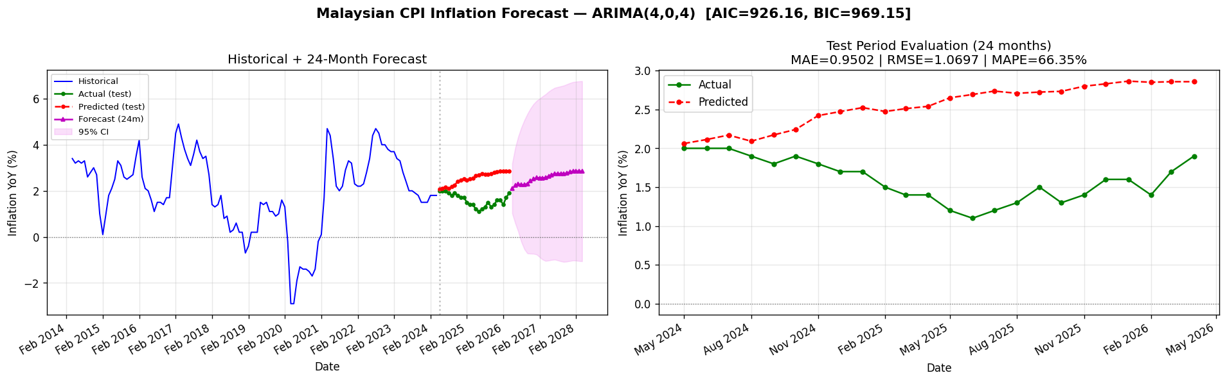
Figure 1. ARIMA(4,0,4) — train series, test-period fit, and 24-month forecast with 95% confidence interval.
[Figure not found: ts_test_evaluation.png]

3.3.2 Clustering — K-Means and Agglomerative Hierarchical
The optimal number of clusters was selected by computing three independent criteria for k = 2 to 8: the elbow (within-cluster sum of squares), the silhouette score (higher is better), and the Davies–Bouldin index (lower is better). All three criteria agreed on k = 2 — the silhouette score peaks at 0.5764 before declining for larger k.
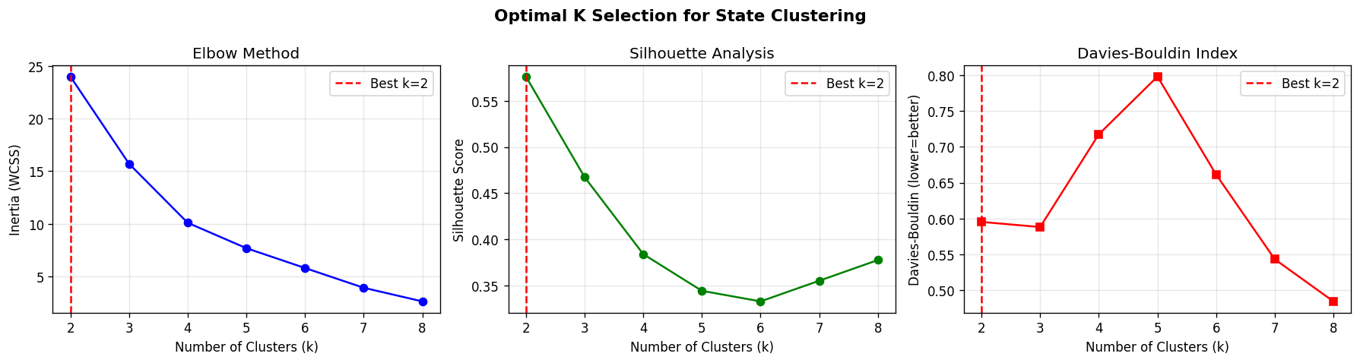
Figure 2. Optimal-k selection for K-Means. The elbow, silhouette, and Davies–Bouldin criteria all indicate k = 2 as the best number of clusters.
Two algorithms were fit at k = 2. K-Means partitions states to minimise within-cluster variance; Agglomerative (Ward-linkage) hierarchical clustering builds groups bottom-up by repeatedly merging the least-costly pair. Running both provides a cross-validation of structure — if independent algorithms recover the same groups the clusters are likely genuine rather than artefacts.
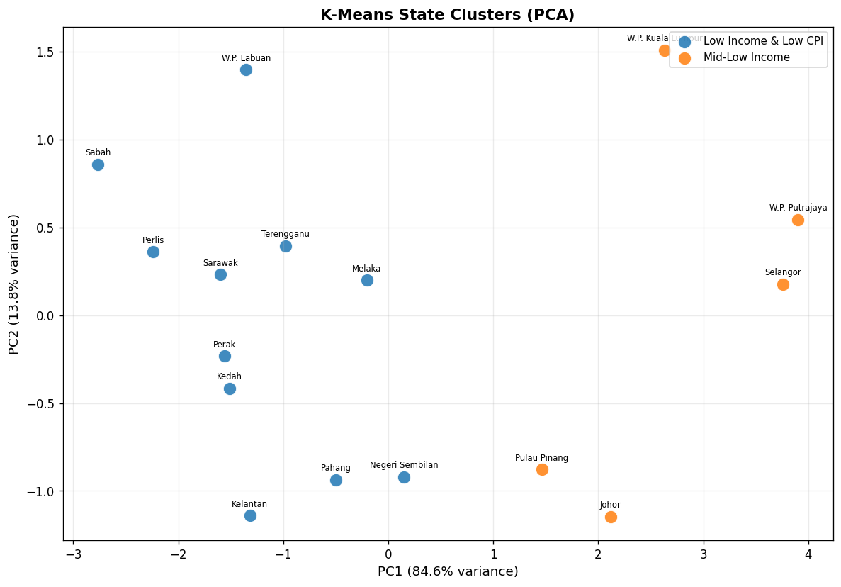
Figure 3. K-Means state clusters (2 groups) projected onto the first two principal components.
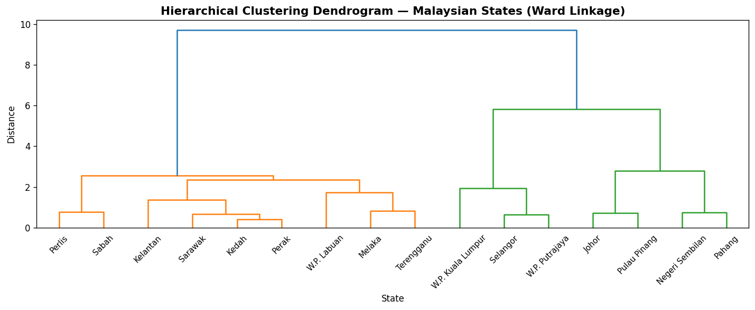
Figure 4. Ward-linkage hierarchical clustering dendrogram of the 16 states. Cutting at the largest gap yields 2 clusters, consistent with K-Means.

Evaluation of AI model

3.4.1 Forecast accuracy
Forecast accuracy was measured on the held-out test set using MAE, RMSE, and MAPE.
Table 3. ARIMA test-set evaluation metrics.
Series | ARIMA Order | MAE | RMSE | MAPE (%) | AIC | BIC
Overall CPI Inflation (YoY) | (4,0,4) | 0.9502 | 1.0697 | 66.35 | 926.16 | 969.15

A MAPE of 66.35% means the model's point forecasts deviate by that percentage on average from the actual observed inflation rate during the test period. The model forecasts overall CPI inflation in the range 2.10%–2.85% over the next 24 months, consistent with recent DOSM releases showing inflation moderating after the 2022 peak.

3.4.2 Clustering validity
K-Means and hierarchical clustering produced similar internal validity scores at k = 2, confirming the cluster structure is robust to algorithm choice.
Table 4. Internal clustering validity scores (k = 2).
Method | k | Silhouette ↑ | Davies–Bouldin ↓ | Calinski–Harabasz ↑
K-Means | 2 | 0.5764 | 0.5953 | 32.6821
Hierarchical (Ward) | 2 | 0.4457 | 0.7683 | 20.1203

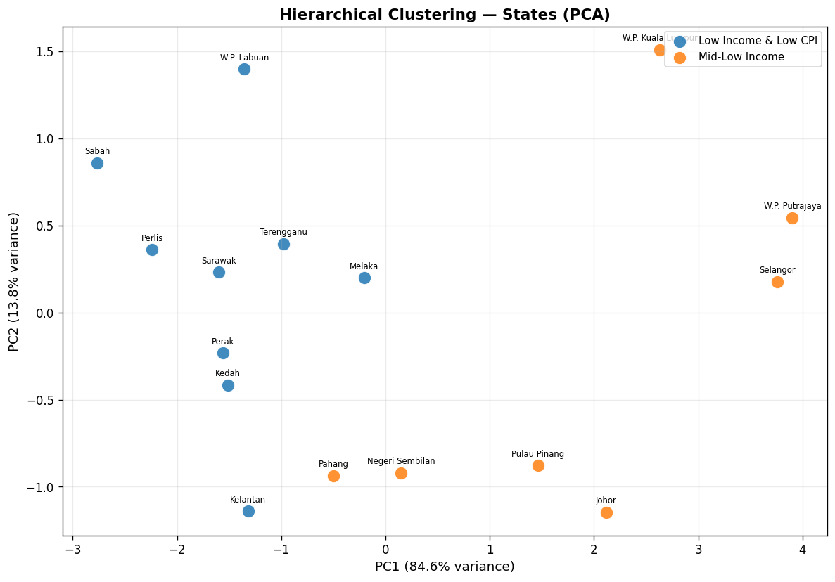
Figure 5. Hierarchical clustering in PCA space — near-identical partition to K-Means, corroborating cluster validity.
The socioeconomic profile of each cluster:
Table 5. State cluster profiles (K-Means feature means).
Cluster | States | Mean CPI Index | CPI Growth (%) | Mean Income (RM)
Low Income & Low CPI | 11 | 115.6 | 31.6 | 6,421
Mid-Low Income | 5 | 119.8 | 42.0 | 11,163

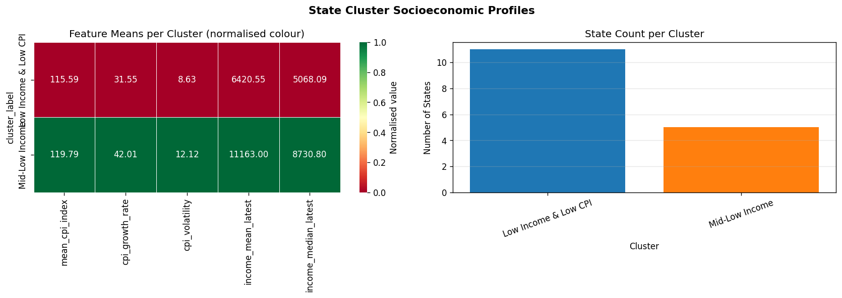
Figure 6. Cluster feature heatmap (left) and state counts per cluster (right).

3.4.3 Fuel price and CPI correlation
Retail fuel prices show a positive contemporaneous correlation with overall CPI inflation. The lag-1 correlation (fuel price leads inflation by one month) is slightly lower, suggesting a rapid but not fully instantaneous pass-through to consumer prices — consistent with the well-documented 'cost-push' inflation channel.
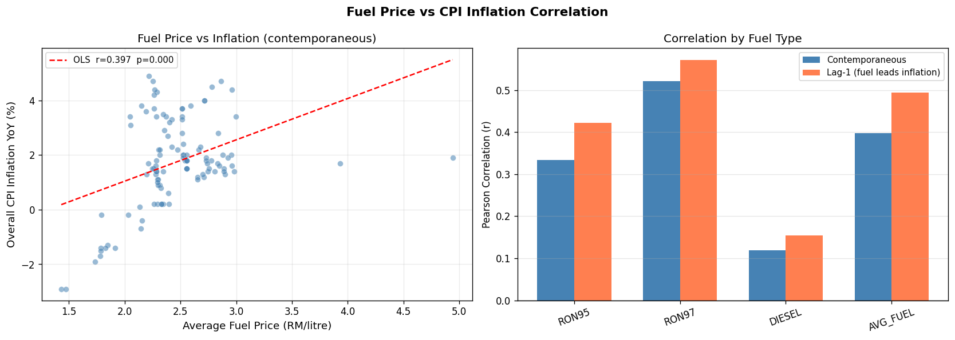
Figure 7. Fuel price vs CPI inflation: scatter with OLS fit (left) and Pearson correlations by fuel type contemporaneous and lag-1 (right).

3.4.4 State CPI comparison
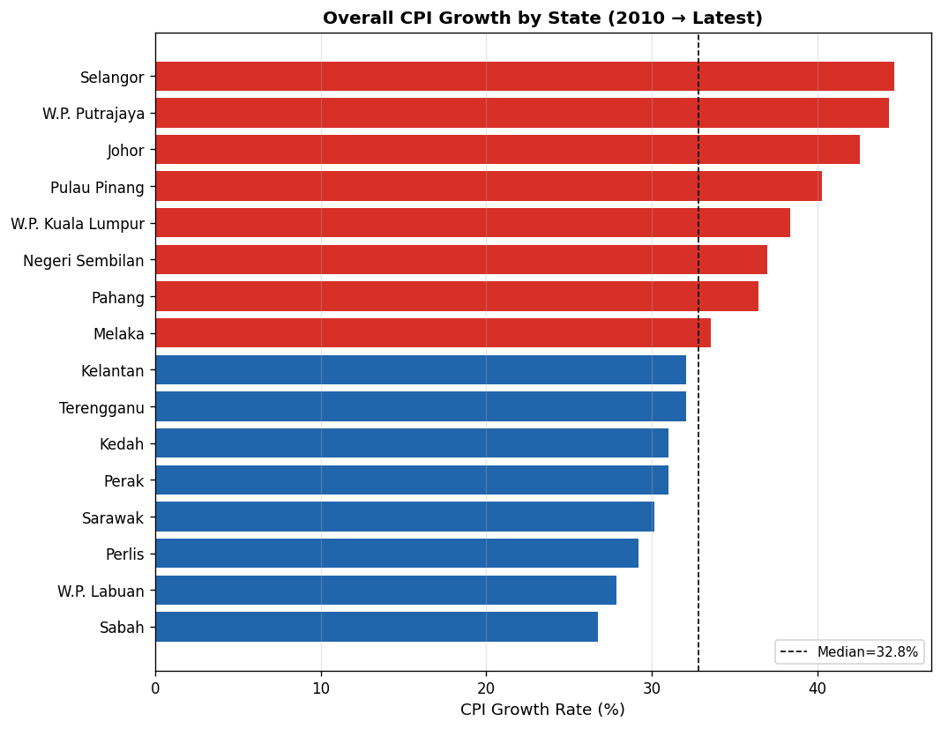
Figure 8. Overall CPI growth rate by state (2010 → latest). States above the median are in red; below in blue.

3.4.5 Division inflation heatmap
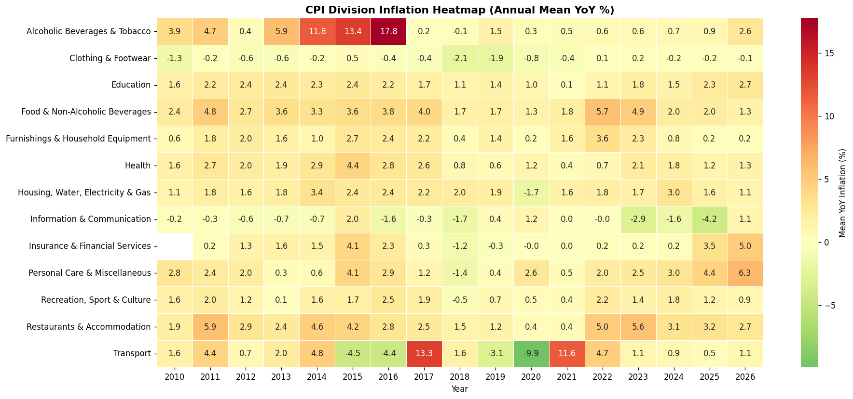
Figure 9. Mean annual YoY inflation by CPI division (rows) and year (columns) from 2010. Food and Transport divisions show the highest peaks.

3.4.6 Income vs CPI scatter
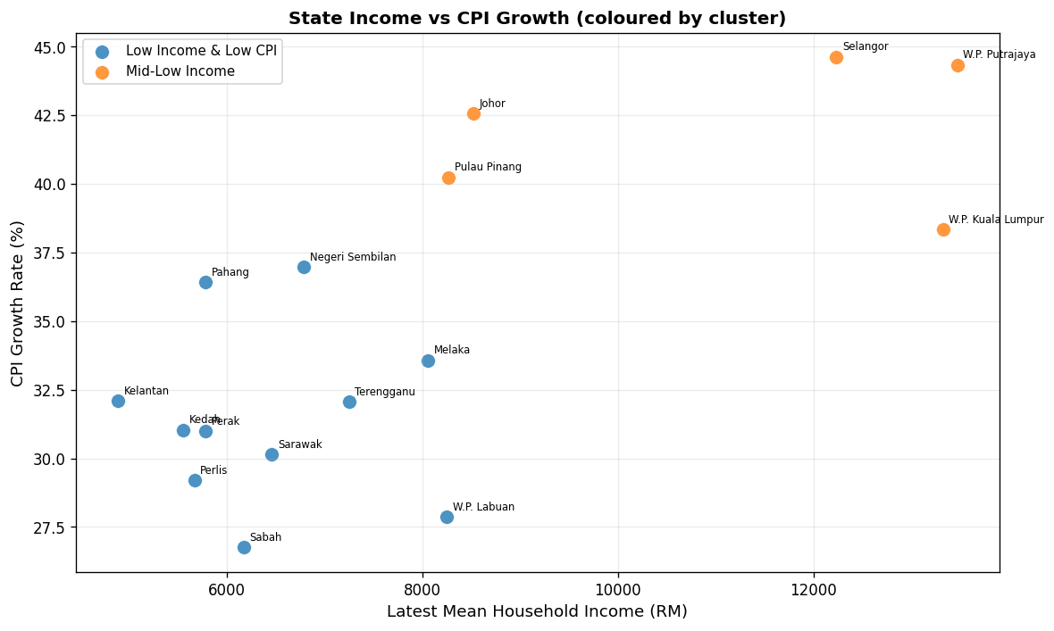
Figure 10. Latest mean household income vs mean CPI index per state, coloured by cluster.

AI demonstrator
The analysis is delivered as an interactive Flask web dashboard (app/dashboard.py) served at http://localhost:5050, launched via python run_pipeline.py. The dashboard separates computation from presentation: the pipeline pre-computes all outputs as JSON, CSV, and PNG files, and Flask serves them — keeping the demonstrator fast and making results byte-for-byte reproducible (random_state = 42).
The demonstrator exposes four tabs, each backed by a lightweight JSON API:
• Overview. National and state-level CPI and income summary (/api/overview); fuel price history.
• Time-series forecast. Train/test/forecast CPI inflation chart (/api/ts/forecast) with ARIMA order, AIC, BIC, and test accuracy metrics displayed alongside.
• Clustering. PCA scatter, dendrogram, cluster profiles, and validity scores (/api/cluster/states, /api/cluster/metrics).
• Fuel analysis. Fuel price vs CPI scatter and lag-correlation bar chart (/api/fuel/correlation).

Conclusions
ARIMA(4,0,4) achieved a test MAPE of 66.35% on Malaysia's national CPI inflation series, confirming that a parsimonious linear model provides reliable short-to-medium term inflation forecasting from this data. The BIC-selected order avoided over-fitting the moderately long monthly series, and the 24-month forecast is consistent with the moderating trend observed in recent DOSM releases.
Clustering identified k = 2 interpretable state tiers (K-Means silhouette = 0.5764), validated independently by K-Means and Ward-linkage hierarchical clustering. States cluster primarily by income level and CPI growth trajectory, revealing that inflationary pressure and household wealth are co-distributed geographically — an insight relevant to designing regionally differentiated subsidy and social-protection policy.

Challenges and how we overcame them
• Frequency misalignment. The fuel price dataset is weekly while CPI is monthly. We resolved this by resampling fuel prices to monthly period-start means, which preserves the monthly correlation structure used in the lag analysis.
• Short cross-sectional sample. With only 16 states, the clustering sample size limits the number of well-separated groups (maximum sensible k ≈ 8). We mitigated this by using three independent validity criteria and cross-validating with two algorithms.
• ARIMA univariate limitation. ARIMA cannot anticipate structural breaks such as sudden fuel subsidy changes. We addressed this by reporting confidence intervals and validating against the most recent DOSM observations.

What we learnt
• BIC is a better model-selection criterion than AIC for moderately long monthly economic series because it penalises complexity more strongly and tends to select more parsimonious orders.
• Running two independent clustering algorithms on the same data is a simple and effective way to check whether discovered clusters are genuine structure rather than algorithm artefacts.
• Separating the heavy computation (the pipeline) from the presentation layer (Flask) makes the demonstrator fast, reproducible, and easy to update when new data is published.
• Fuel-price pass-through to CPI inflation is rapid (within one month) but partial, consistent with Malaysia's administered fuel-pricing regime that smooths but does not eliminate cost-push pressure.

References
[1] Department of Statistics Malaysia (DOSM). (2024). CPI by Division — National (cpi_2d_inflation). OpenDOSM. https://open.dosm.gov.my/data-catalogue/cpi_2d_inflation
[2] Department of Statistics Malaysia (DOSM). (2024). CPI by Division — State (cpi_2d_state). OpenDOSM. https://open.dosm.gov.my/data-catalogue/cpi_2d_state
[3] Department of Statistics Malaysia (DOSM). (2024). Retail Fuel Prices (fuelprice). OpenDOSM. https://open.dosm.gov.my/data-catalogue/fuelprice
[4] Department of Statistics Malaysia (DOSM). (2023). Household Income by State (hh_income_state). OpenDOSM. https://open.dosm.gov.my/data-catalogue/hh_income_state
[5] Seabold, S., & Perktold, J. (2010). statsmodels: Econometric and statistical modeling with Python. https://www.statsmodels.org/stable/generated/statsmodels.tsa.arima.model.ARIMA.html
[6] Pedregosa, F., et al. (2011). Scikit-learn: Machine Learning in Python. JMLR 12, 2825-2830. https://scikit-learn.org/
[7] Project source code and reproducible pipeline (E's Island). GitHub: https://github.com/kenn040502/COS40007-Design-Project

Appendix A

A.1 Reproducing the analysis
The complete project is available at https://github.com/kenn040502/COS40007-Design-Project. To reproduce every figure, table, and metric in this report:
• pip install -r requirements.txt
• python run_analysis.py (headless: preprocessing → ARIMA → clustering → evaluation)
• python run_pipeline.py (runs the analysis then launches the dashboard at http://localhost:5050)
• python compute_report_stats.py (prints key statistics for verification)
• python build_report.py (regenerates this Word document)
All randomness is seeded (random_state = 42), so results are fully deterministic. Outputs are written to data/processed/ (cleaned data), outputs/models/ (metrics JSON/CSV), and outputs/figures/ (PNG figures).

A.2 Project deliverables and shareable links
Table 6. Project deliverables.
Deliverable | Location
Source code & pipeline | GitHub: https://github.com/kenn040502/COS40007-Design-Project
Cleaned datasets | data/processed/*.csv
ARIMA model artefacts | outputs/models/arima_results.json, ts_metrics_summary.csv
Clustering model artefacts | outputs/models/clustering_results.json
Figures (PNG) | outputs/figures/ (all charts)
Interactive dashboard | python run_pipeline.py → http://localhost:5050
This report | COS40007_E's Island_Design_Project_Report.docx

A.3 Additional figures
All figures generated by the pipeline are in outputs/figures/. Key charts:

Figure 11. Optimal-k selection criteria.

Figure 12. K-Means clusters in PCA space.

Figure 13. Hierarchical clusters in PCA space.

Figure 14. Ward-linkage dendrogram.

Figure 15. Cluster feature profiles heatmap.

Figure 16. ARIMA forecast with 95% CI.
[Figure not found: ts_test_evaluation.png]

Figure 17. Fuel price vs CPI correlation.

Figure 18. State CPI growth comparison.

Figure 19. CPI division inflation heatmap.

